Homework 1 – Color Transform
314552046莊明憲
SPEC
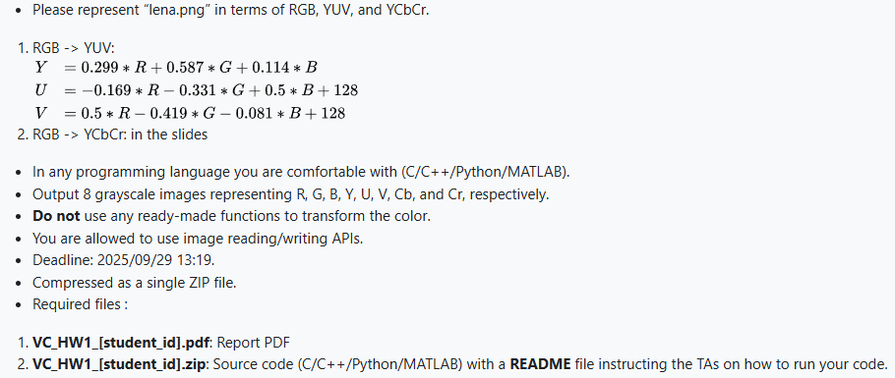
Code Explanation
- Initial setup
Load the source image lena.png safely, convert it into floating point Numpy array, and ensures that the output directory for results exists.
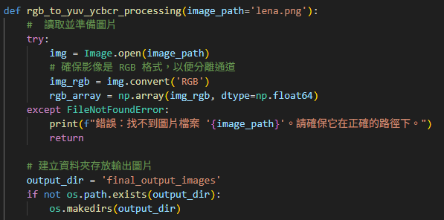

- Color space transformation
First, it separates R, G, B channels from the input image data. It then applies the two sets of math formulas provided in slides and spec to compute the Y, U, V, Cb, Cr color space channels.
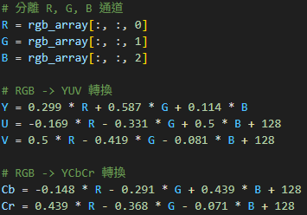
- Image saving
It gathers all eight computed image channels (R, G, B, Y, U, V, Cb, Cr) into a dictionary. The code then iterates through this dictionary, converting each channel's data into a standard 8-bit grayscale image and saving it as a separate .png file.
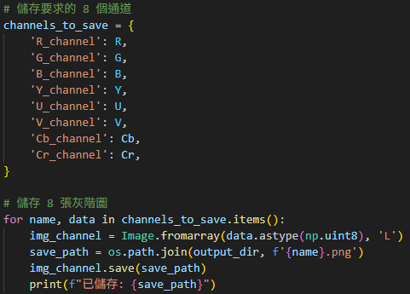
- Main block
This is the main entry point of the Python script. When the program is run, this block of code calls the primary processing function to start the entire color conversion and image saving process.
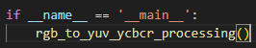
Result
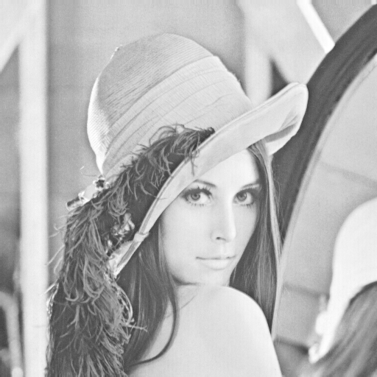 | 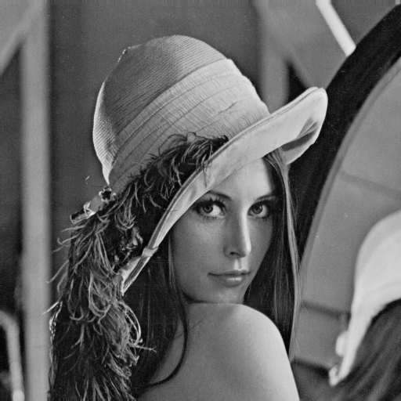
R | G
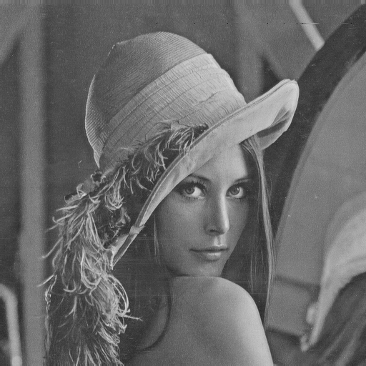 | 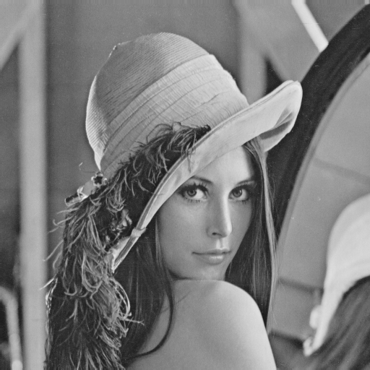
B | Y
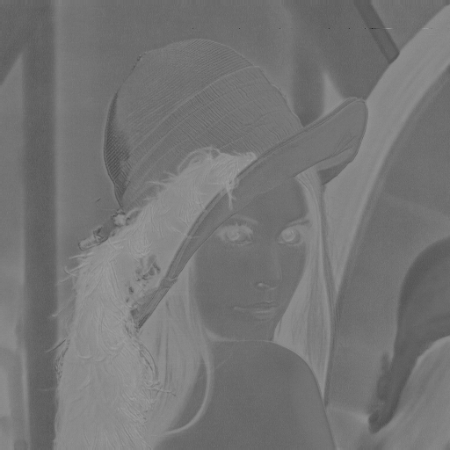 | 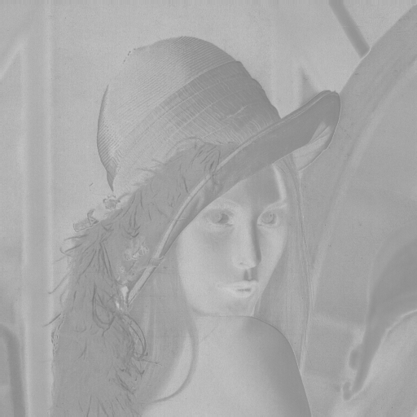
U | V
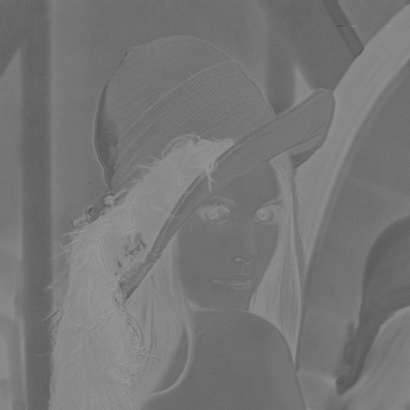 | 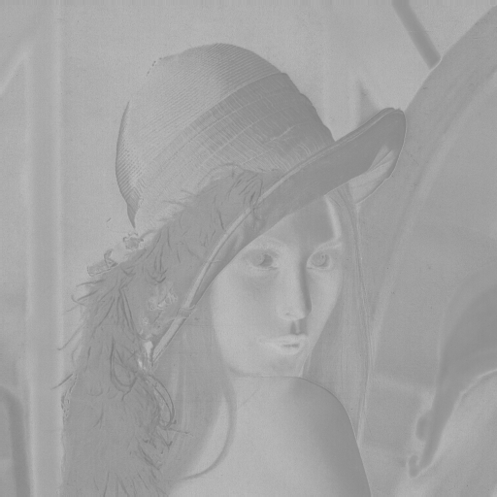
Cb | Cr

